PRACTICE 3.3. HQL. CREATING HQL QUERIES

OBJECTIVE: Create HQL queries and programming with it.

# REALIZATION:

We will use the session method “**createQuery(hql_sentence).list()**”. This method returns a list with all the rows satisfying the query.

List myList = session.createQuery("hql_sentence").list();

We will use the interface “Iterator”, imported from java.util.*;

Iterator it= myList.iterator();

while(it.hasNext()){

Class_of_object ob= (Class_of_object) it.next();

}

STEP 1: In our class HibernateEnterprise create a new method showing all products with the HQL sentence “from Products”:

**public** **void** showProducts(){

Session session = *sf*.openSession();

Transaction tx = **null**;

**try** {

tx = session.beginTransaction();

List allproducts = session.createQuery("FROM Products").list();

Iterator iterator = allproducts.iterator();

**while**(iterator.hasNext()){

// for (Iterator iterator = allproducts.iterator(); iterator.hasNext();){

Products p = (Products) iterator.next();

System.***out***.print("Id: " + p.getProductId());

System.***out***.print(" ,Name: " + p.getName());

System.***out***.println(" ,Price: " + p.getPrice());

}

tx.commit();

} **catch** (HibernateException e) {

**if** (tx!=**null**) tx.rollback();

e.printStackTrace();

} **finally** {

session.close();

}

}

PRINTSCREEN: THE RESULT BY CONSOLE

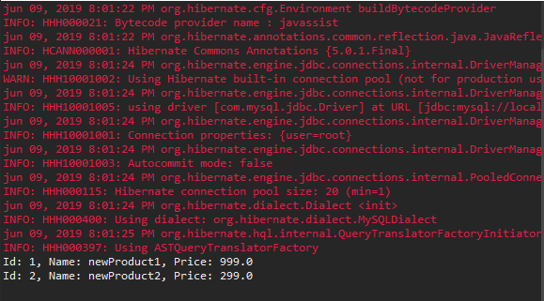

STEP 2: Changing the HQL sentence, do methods to show:

* void showByName(String name): All the products that have the word “name”.

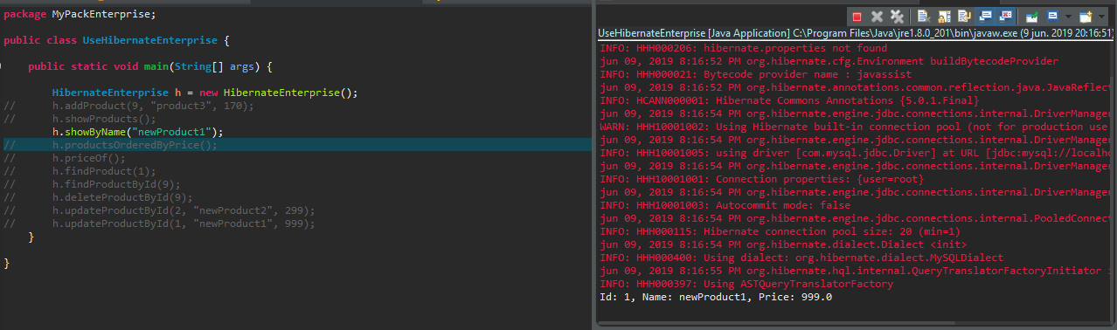

* void productsOrderedByPrice(): shows all the products ordered by price

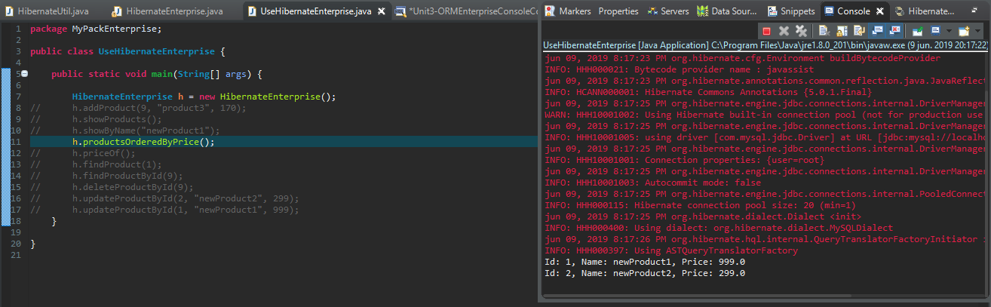

* void priceOf(String name): Ask the user for the name of a product by console, and look for the price in the database. The method must show how many products have that name and then show all the information about the products.

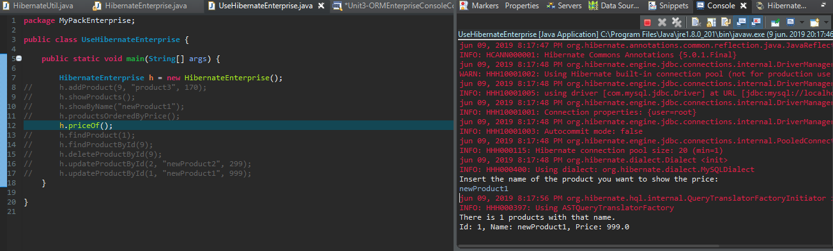

* void findProduct(int id): Using the method uniqueResult, look for a product with an id and show all the information of the product

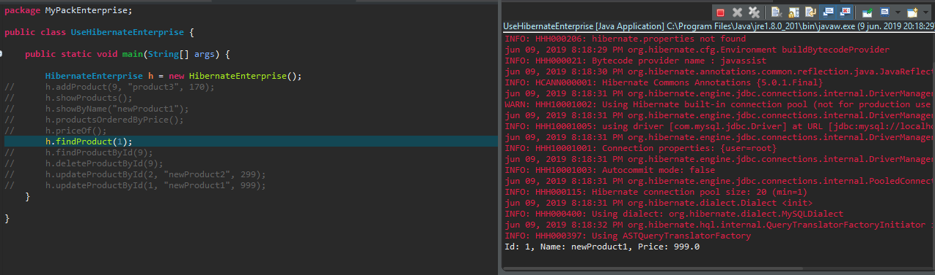

PRINTSCREEN: FOR EACH METHOD, THE CODE AND THE RESULT WHEN EXECUTING IT.

The code is also attached in the .rar